Linear Modelling
Lee Barnby
2024-10-21

Introduction to Linear Modelling
This tutorial will introduce you to linear modelling using R. We will cover simple linear regression, multiple linear regression, and how to interpret the results.

Prerequisites
- Basic understanding of R programming
- Familiarity with statistical concepts

Setup
# Install necessary packages
#install.packages("ggplot2")
#install.packages("dplyr")
# Load packages
library(ggplot2)
library(dplyr)
##
## Attaching package: 'dplyr'
## The following objects are masked from 'package:stats':
##
## filter, lag
## The following objects are masked from 'package:base':
##
## intersect, setdiff, setequal, union

Simple Linear Regression

Example: Traffic Density and Speed
We will use a dataset that relates traffic (vehicle) density to average traffic speed.
# Data
density <- c(69, 88, 65, 84, 63, 53, 82, 53, 70, 33)
speed <- c(16.8, 14.8, 19.1, 14.9, 21.6, 25.7, 16.8, 25.1, 19.7, 31.5)
# Scatterplot
plot(density, speed, main="Traffic Density vs Speed", xlab="Density", ylab="Speed")
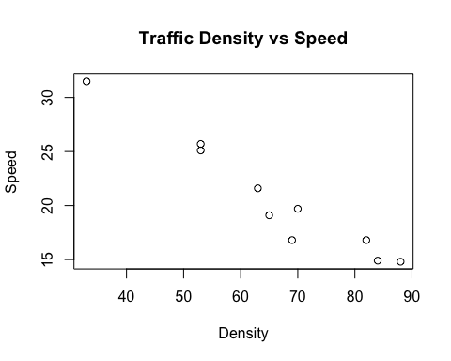

Linear Regression Model
# Linear model
lm_model <- lm(speed ~ density)
summary(lm_model)
##
## Call:
## lm(formula = speed ~ density)
##
## Residuals:
## Min 1Q Median 3Q Max
## -2.85938 -0.02738 0.38907 0.90629 1.21663
##
## Coefficients:
## Estimate Std. Error t value Pr(>|t|)
## (Intercept) 41.29359 1.89926 21.74 2.11e-08 ***
## density -0.31354 0.02798 -11.21 3.60e-06 ***
## ---
## Signif. codes: 0 '***' 0.001 '**' 0.01 '*' 0.05 '.' 0.1 ' ' 1
##
## Residual standard error: 1.406 on 8 degrees of freedom
## Multiple R-squared: 0.9401, Adjusted R-squared: 0.9326
## F-statistic: 125.6 on 1 and 8 DF, p-value: 3.603e-06

Interpretation of Results
- Coefficients: The intercept and slope of the regression line.
- R-squared: Indicates how well the model explains the variability of the response data.
- p-value: Tests the null hypothesis that the coefficient is equal to zero (no effect).

Confidence Intervals
Let’s predict the speed at traffic densities of 40 and 65 with confidence intervals.
# Confidence intervals for predictions
predict(lm_model, data.frame(density=c(40, 65)), interval="confidence")
## fit lwr upr
## 1 28.75202 26.78606 30.71798
## 2 20.91354 19.88615 21.94093
Does this make sense? Check the plot. The confidence intervals are quite wide, so the model is not very accurate, at least for some values of speed. This is likely due to the small sample size.
Try different values. Do you see any problems with the model as you extend the range.
Look at the differnet ‘interval’ options.

Multiple Linear Regression

Example: Retail Shop Sales
We will analyze the relationship between sales and several predictor variables.
# Data
sales <- c(4, 3, 4, 6, 7, 2, 6, 10, 5, 3)
competitors <- c(3, 4, 6, 3, 1, 5, 1, 0, 2, 5)
management <- c(1, 2, 3, 4, 5, 6, 7, 8, 9, 10)
promotions <- c(3, 5, 7, 5, 2, 6, 2, 1, 3, 6)
key_traders <- c(1, 2, 3, 3, 2, 1, 2, 3, 1, 2)
advertising <- c(3, 3, 3, 2, 2, 2, 2, 4, 4, 4)
# Data frame
data <- data.frame(sales, competitors, management, promotions, key_traders, advertising)
# Multiple linear regression model
mlm_model <- lm(sales ~ competitors + management + promotions + key_traders + advertising, data=data)
summary(mlm_model)
##
## Call:
## lm(formula = sales ~ competitors + management + promotions +
## key_traders + advertising, data = data)
##
## Residuals:
## 1 2 3 4 5 6 7 8 9 10
## 0.1754 -0.9446 0.3970 0.1754 0.2785 0.5268 -0.7947 0.3868 0.2569 -0.4576
##
## Coefficients:
## Estimate Std. Error t value Pr(>|t|)
## (Intercept) 4.61705 1.31426 3.513 0.0246 *
## competitors -0.46162 0.94941 -0.486 0.6522
## management 0.03657 0.12593 0.290 0.7859
## promotions -0.48222 0.90159 -0.535 0.6211
## key_traders 1.50953 0.45610 3.310 0.0297 *
## advertising 0.16432 0.41790 0.393 0.7142
## ---
## Signif. codes: 0 '***' 0.001 '**' 0.01 '*' 0.05 '.' 0.1 ' ' 1
##
## Residual standard error: 0.7942 on 4 degrees of freedom
## Multiple R-squared: 0.9495, Adjusted R-squared: 0.8865
## F-statistic: 15.05 on 5 and 4 DF, p-value: 0.01058

Interpretation of Results
- Coefficients: The effect of each predictor variable on sales.
- R-squared: Indicates how well the model explains the variability of the response data.
- p-value: Tests the null hypothesis that the coefficient is equal to zero (no effect).

Prediction Intervals
# Prediction intervals for new data
predict(mlm_model, data.frame(competitors=5, management=1, promotions=6, key_traders=3, advertising=4), interval="prediction")
## fit lwr upr
## 1 4.63802 1.460057 7.815984

Diagnostics and Model Validation

Diagnostic Plots
# Diagnostic plots
par(mfrow=c(2,2))
plot(lm_model)
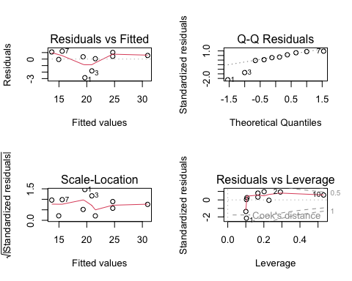

Interpretation of Diagnostic Plots
- Residuals vs Fitted: Checks the linearity assumption.
- Normal Q-Q: Checks the normality of residuals.
- Scale-Location: Checks the homoscedasticity assumption.
- Residuals vs Leverage: Identifies influential data points.

Conclusion
This tutorial covered the basics of linear and multiple linear regression using R. We discussed how to fit models, interpret the results, and validate the models using diagnostic plots.

Feel free to expand on each section with more detailed explanations and additional examples as needed. If you have any specific questions or need further assistance, let me know.

